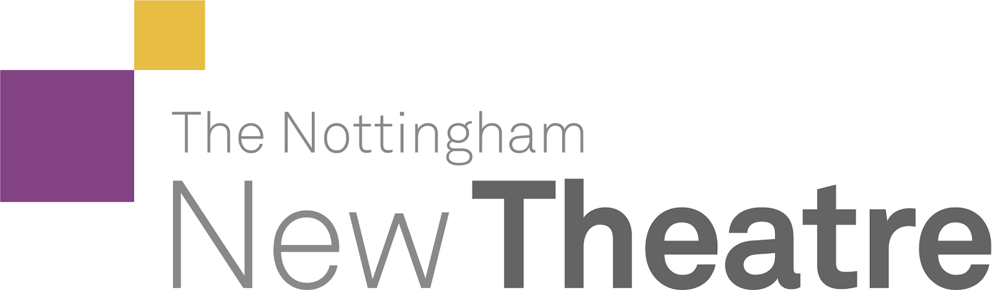

EdFringe Proposal Form

This form must be emailed to edinburgh@newtheatre.org.uk by 23:59 on Wednesday 28th April. The Virtual Proposals Day will be on Saturday 1st May. Handwritten forms will not be accepted. All questions must be answered. If you have any questions about this form, please email the relevant committee members, their emails can be found here: About · The Nottingham New Theatre or consult the Edinburgh Proposals Pack.

KEY INFORMATION
Your answers here:
Name of Director
Director’s Phone Number
Name of Producer
Producer’s Phone Number
Title of Play
Playwright
Are the Performance Rights available? y/n
Approximate Running Time
Cast Breakdown - M/F/GN (as specified in script)
Do you plan to cast any of these roles as gender bent / gender neutral?
(If so please outline the new cast breakdown)
If YES to above, has permission been granted?
Total Budget
Would you be happy for your form to be shared with other teams?

Synopsis - 100 Words
A 100-150 word blurb for your show to be used on the audition handout, for StuFF and for online advertising on the Fringe website.

Description - 40 Words
This short description will be used in the Fringe handbook to sell your show.

Characters
Please give the name, a brief description, an approximate percentage stage time AND an approximate percentage speaking time (i.e. the percentage of the whole play this character speaks for) for each listed character. If you are planning to gender-bend characters or cast as gender neutral, please specify this here.

Plot Summary
Please give a brief scene-by-scene breakdown of your play.

WELFARE CONSIDERATIONS

Content Warning Breakdown
Does your play contain any scenes of a violent, sexual or adult nature, or have any other associated content warnings? Please detail what happens in each relevant scene, and how you plan to combat these elements for both the team involved and the audience watching them.

Content Warning | Section of Play | Description of Content Warning

Considerations for Cast and Crew
What steps do you intend to take to look after the welfare of your cast and crew during this process?

Considerations for Production Teams
What steps do you intend to look after your own welfare during this process?

Considerations for Audience
What steps do you intend to take to look after the welfare of your audience during the show?

Age Certification
Please use the grid provided in the Proposals Pack to identify the most appropriate age guideline for your show. Use this information to identify for each category whether your show is appropriate for ‘Under 12s’, 12+, 15+, or 18+.

Your show’s certification
Dangerous behaviour
E.g. self-harm, suicide, asphxiation
Discrimination
Drugs and smoking
(Including alcohol misuse)
Language
Nudity
Sex
Threat and horror
Violence and sexual violence

Have You Talked to the Relevant Member of Committee
Alice Walker - secretary@newtheatre.org.uk

INTERPRETATION

What is your interpretation of the play? Why does this specific interpretation work for The Nottingham New Theatre?
300 – 500 words
In particular it may help to think why you have chosen this play to perform here, now, and why you are the right person to put it on. If it is a piece of student writing perhaps you could explain to us what made you choose to write about the themes you have chosen.

Why have you picked this play for the Edinburgh Festival Fringe? What makes it Edinburgh appropriate?
300 – 500 words

What are some of the Key Challenges you think you will face, and how do you plan on dealing with them?
300 words MAX

What is your plan for approaching the show considering the potential limitations of government restrictions?
What plans will you put in place to ensure that the development of your show can continue regardless of ever changing restrictions?
300 words MAX

BACKSTAGE
When discussing the following elements, please keep in mind the limitations of the Edinburgh Festival Fringe. This year we are in Perth Theatre with theSpace. There is a possibility that an alternate outside venue will be used. Hopefully this will closely resemble Perth Theatre but your design may require downsizing. Please see the Proposals Pack for more information.

Set Design
A clear, labelled and to scale diagram (with measurements where appropriate) should be inserted into the document here. Please also include an explanation of how you will construct any complicated set pieces. Technical language is not required.

200 words MAX

Costume Design
Please provide a detailed breakdown of the costume for each character. It is advised that you include pictures/sketches/etc. Contact Charlie Basley for information on what we have wardrobe@newtheatre.org.uk

200 words MAX

Make-up Design
Please provide a detailed breakdown of the hair and make-up for each character. It is advised that you include pictures/sketches/etc.

Have You Talked to the Relevant Member of Committee
Nick Landon - ‘cmc@newtheatre.org.uk’, Barney Hartwill - ‘theatremanager@newtheatre.org.uk’, Charlie Basley - ‘costume@newtheatre.org.uk’, Pete Rouse - ‘csm@newtheatre.org.uk’

TECH

Lighting Design
Be clear with your ideas for specific colours, spotlights, etc. Feel free to include pictures/sketches/etc. Technical language is not required.

Sound Design
This can be referring to music, sound effects or live on-stage sounds. Feel free to include links to sounds or music. Technical language is not required.

Video Design (Optional)
Include notes here if you are using TVs on-stage, or projection of any sort. Feel free to include pictures/sketches/links to videos that inspire you or you would like to use etc. If you are planning on creating videos for the show, make clear what you would like to do. Technical language is not required.

Have You Talked To The Relevant Member of Committee
In this instance either Cecilia Alexander ‘techmanager@newtheatre.org.uk’ or Tara Anegada ‘techdirector@newthatre.org.uk’

PUBLICITY

Poster Design
You do not need a finished poster for proposals, merely an idea or concept to inspire it. It is advised that you include pictures/sketches/etc.

Please outline any ideas you have for the design of publicity materials: Posters, listing icon, flyers, trailers, etc.

Marketing Strategy
Who are you going to target with your publicity, and how will you attract them to your show?

Who is your target audience?

How do you plan on advertising your show to the public? What will make your show stand out on the Mile amongst thousands of others?

How will you use the NNT social media accounts (Facebook, twitter, instagram, etc.) to publicise your show during the festival?

Have You Talked to the Relevant Member of Committee
Ella Seber-Rajan, Ace Edwards - ‘publicity@newtheatre.org.uk’

BUDGET BREAKDOWN

Proposed Total Budget:
Performance Rights (inc. VAT):

Set Budget | Total:

Item | Sourced From / Link | Price (Incl. Delivery)

Technical Budget: | Total:

Item | Sourced From / Link | Price (Incl. Delivery)

Costume Budget: | Total:

Item | Sourced From / Link | Price (Incl. Delivery)

If you are intending to hire costumes, what company do you intend to use?

Props Budget: | Total:

Item | Sourced From / Link | Price (Incl. Delivery)

Make-up Budget | Total:

Item | Sourced From / Link | Price (Incl. Delivery)

Publicity Budget: | Total:

Item | Sourced From / Link | Price (Incl. Delivery)

Miscellaneous Budget: | Total:

Item | Sourced From / Link | Price (Incl. Delivery)

Have You Talked To The Relevant Member of Committee
Sofia Loreti - ‘treasurer@newtheatre.org.uk’

SCRIPT EXTRACT

We request that each team submits an extract from the script they wish to propose. We ask for 4 pages (2 double pages) of your chosen script. You may choose any part of the script, but it must be 4 sequential pages.
If you are proposing student or new writing, in addition to the 4-page extract here, we request a full script to be submitted separately to the form, or the full amount that has been written by the date of proposals. If the script is not completed by proposals, then you must also attach a writing schedule. If you are devising, please provide a devising schedule.
This extract can be inserted into the proposals form as a scan or typed up. If it is typed it must be equivalent to four pages in the hard-copy version. If the play is available to read online, either in the public domain or on dramaonline feel free to include a link to the script.

